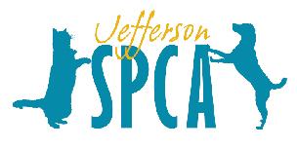
Wish List
www.jeffersonspca.org

- donations to the Jefferson SPCA Heartworm Treatment Fund for shelter dogs
- British slip leashes
- Easy Walk harnesses (prefer large and medium)
- Kongs (original large type for dogs)
- large plastic storage containers
- Pup-Peroni
- Nylabones
- small soft dog treats for training
- small Milk dog biscuits
- pens
- Sharpies
- Dry erase markers
- small dog collars
- leashes
- card stock
- colored copy paper
- dog shampoo
- towels
- poop bags
- cat toys
- ping pong balls
- newspapers
- gift cards to Walmart, Home Depot, Lowes, Office Depot, Petsmart, Petco, Jefferson Feed....

- Also see our Amazon wish list: http://www.amazon.com/gp/registry/wishlist/ref=cm_wl_search_1?ie=UTF8&cid=A27F5DAJV8636U

